**tronICs**

**DIGITAL CIRCUIT DESIGN EVENT**

**Instruction:** Email the answers to the questionnaire to **probe.events2020@gmail.com** with “tronICs_<*your team name*>” as the subject. Also mention the **names** and **Probe IDs** of **all the team members** in the Email. **Deadline: 24th January 2020**.

Questions 1-5 are Multiple Choice Questions. Indicate the correct option against “Answer:”.

For questions 8-10, based on circuit design attach images of necessary circuit diagrams.

1. **What is the maximum number of prime implicants for an n - variable Boolean function?** 
   1. 2(n-1)
   2. n/2
   3. 2^n
   4. 2^(n-1)

**Answer:**

1. **Latches constructed with NOR and NAND gates tend to remain in the latched condition due to which configuration feature?**
2. Synchronous operation
3. Low input voltages
4. Cross Coupling
5. Gate impedance

**Answer:**

1. **How many MUX are used to construct a D flip flop (for a MUX only implementation, no external logic gates allowed)?**
2. 4
3. 3
4. 2
5. 1

**Answer:**

1. **An analog signal has 0 V to 8 V range. How many possible digital states does it have?**
2. 8
3. 16
4. 80
5. Infinite

**Answer:**

1. **To design an OR gate minimum number of half-adders required:**
2. 1
3. 2
4. 3
5. 4

**Answer:**

1. **What will be the output of the flipflops at the 3rd rising edge of clock pulse? (Assuming the initial states are Q0 = 1 and Q1=0 before clock input)**

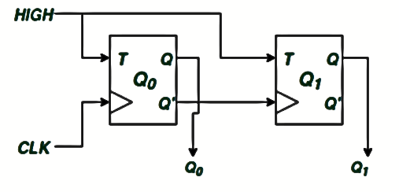

**Answer:**

1. **In the following circuit, what will be the output after the 5th clock pulse? (Assuming the initial states are Qa,Qb,Qc,Qd = 0 before clock input)**

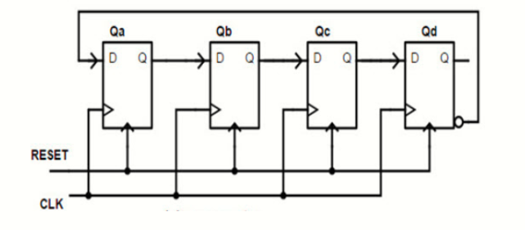

**Answer:**

1. **Given an ‘n’ bit binary number, devise a logic circuit which gives out the base 2 logarithm of the number as output. (For Example: Input = 8 (1000) Output = 3 (11) )**

**Answer:**

1. **Implement the logic function Y = A XOR B XOR C using MUXes only. (Use minimal number of components.)**

**Answer:**

1. **The Octals are a superelite society which uses 4 bit binary codes as identities. The Hexadecimals are an enemy society which also uses 4 bit binary codes as identities.**

**4 Hexadecimals try to pass off as Octals, 2 succeed while 2 do not. When the Hexadecimals who failed to pass off as Octals keep pondering about the reason they weren’t able to succeed, a renegade Octal tells them that the identities they use are actually 3 bit codes and the last bit is used to check if that 4 bit code is a valid identity.**

**It is observed that 0000 and 1100 could pass off as Octals while 0111 and 1011 couldn’t.**

**To help the 2 Hexadecimals pass off as Octals, generate random 3 bit identities for them and figure out a way to add the last bit so that they get valid identities.**

**Also design a circuit for the Octals to check if an identity is valid. (Hints: PRBS, XOR)**

**Answer:**

Best of Luck!

**For queries, mail us at probe.events2020@gmail.com**